**Introduction**

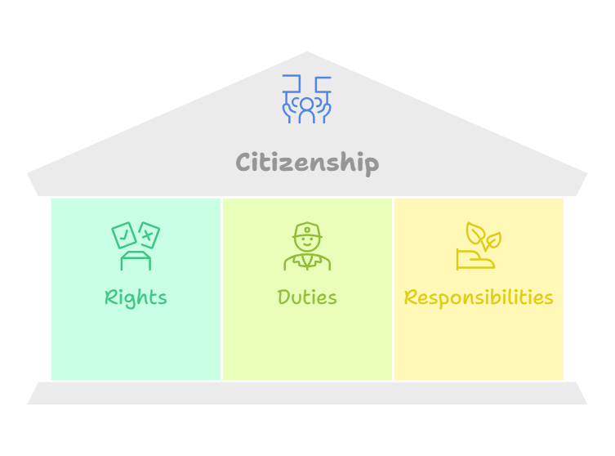Citizenship is the status of being a recognized member of a state or nation, which comes with certain rights, duties, and responsibilities. It involves the relationship between the individual and the state, including participation in the political, legal, and social systems of the country. Citizens typically have the right to vote, work, and live in the country, as well as the obligation to obey its laws and contribute to the community.

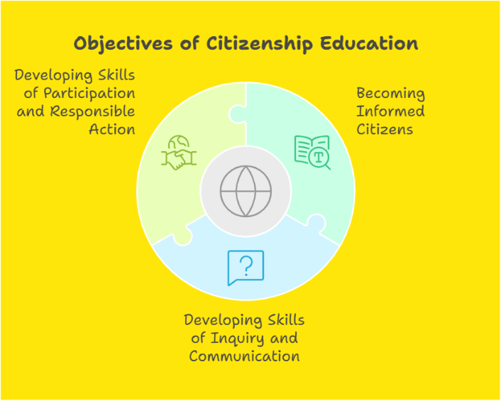

**Objectives of Citizenship Education**

The objectives of Citizenship Education are designed to help individuals/students become informed, active, and responsible members of society.

* **Becoming Informed Citizens:**
  + Understand political, legal, and social systems.
  + Know your rights and responsibilities.
  + Stay updated on local, national, and global issues.
* **Developing Skills of Inquiry and Communication:**
  + Ask questions and seek information.
  + Think critically about issues.
  + Improve communication skills (expressing views and listening to others).
* **Developing Skills of Participation and Responsible Action:**
  + Participate actively in community and civic life.
  + Take responsible actions that benefit society.
  + Develop social and moral responsibility.

**Opportunities**

Citizenship education provides opportunities for students to develop the key skills of:

* **Communication**: Students learn to talk about social, political, and community issues by researching and sharing ideas with others.
* **Application of Number**: They use numbers and statistics to understand and evaluate how data is used in different situations, especially in social and political contexts.
* **Information Technology**: Students use technology to explore and analyze different issues, helping them become more comfortable with digital tools.
* **Working with Others**: They practice working in groups, sharing ideas, and taking part in community activities, which teaches them teamwork.
* **Improving Learning and Performance**: Students reflect on their own progress and set goals to get better at what they do.
* **Problem Solving**: They engage in real-life issues, learning how to find and implement solutions to challenges in their communities.
* **Thinking Skills**: Students learn to think critically by engaging with social issues, using reasoning, and evaluating different perspectives.
* **Financial Capability**: It teaches students about the role of money in society and how to manage it effectively, helping them develop good financial habits.

**Why Teach Citizenship?**

Citizenship education is important because democracies need active, informed, and responsible citizens. These citizens should be engaged in their communities and contribute to the political process. Simply living life or working isn't enough to develop these qualities; they need to be learned. Citizenship education helps people become more involved in national and community issues, understand their rights, and take on civic responsibilities. Even in democratic countries, both people and governments work hard to improve citizenship education.

**What are Its Essential Elements?**

Citizenship education includes:

1. **Knowledge and Understanding**: Learning about laws, democracy, the media, human rights, diversity, money, the economy, and global issues. It also covers concepts like democracy, justice, equality, freedom, authority, and the rule of law.
2. **Skills and Aptitudes**: Developing abilities such as critical thinking, analyzing information, sharing opinions, participating in discussions and debates, negotiating, resolving conflicts, and engaging in community activities.
3. **Values and Dispositions**: Learning to respect justice, democracy, and the rule of law; being open, tolerant, and courageous in defending opinions; and being willing to listen, collaborate, and stand up for others.

On the other hand, there are eight essential components of good Citizenship education:

1- The nature of community.

2- Roles and relationship in a purist society.

3- The duties, rights and responsibilities to being a citizen.

4- The family, gender equality.

5- Democracy in action: process and concept of social justice.

6- The citizen and the law.

7- Work, employment and leisure.

8- Public service.

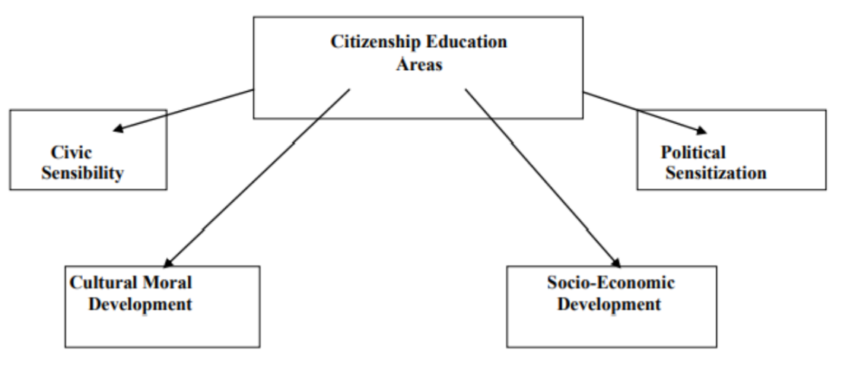

The literature review identifies four key components/areas of citizenship education:

1. **Civic Sensibility**
2. **Socio-Economic Development**
3. **Cultural Moral Development**
4. **Political Sensitization**

Citizenship education should include these elements, which focuses on both knowledge and skills. Students need to understand their roles, rights, and responsibilities as citizens, and grasp political processes like mediation and decision-making. They should be aware of current events, the media’s influence on public opinion, and how money and sponsorship can affect media coverage.

Additionally, students should learn about major historical events and view history, politics, and social issues from different perspectives. This approach helps them develop critical thinking, problem-solving, and debate skills. The main goal of citizenship education is to prepare students to be responsible and effective citizens in a democratic society.